MY QOI Deployment Guide

# Deployment Steps for Mobile App

1. Zip up the “dist” folder as MyQOI.zip located at fresno-myQoI-chrome/extension/myqoi/dist
2. Log into the Chrome Web Store with the myqoidev email address. See Adam or Sam for details.
   1. https://chrome.google.com/u/4/webstore/devconsole/e362b94f-595f-434a-89e2-062ef46ffa45
3. Click on MyQOI  
   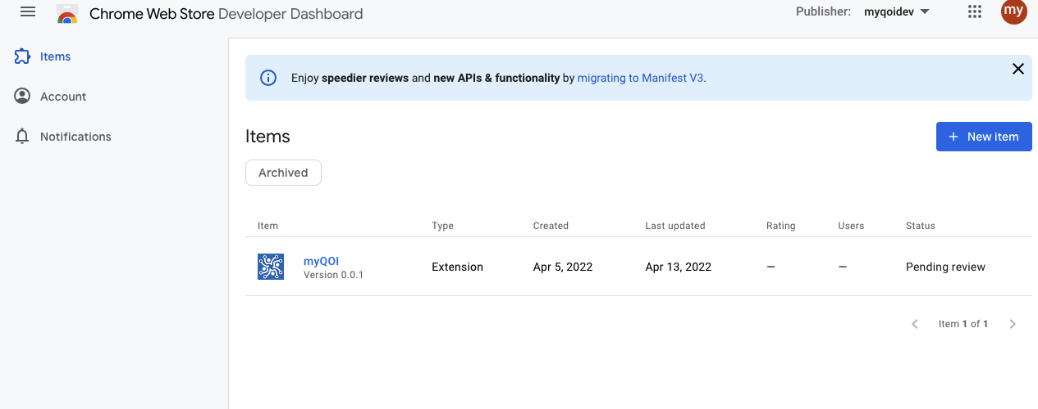
4. Click Package  
   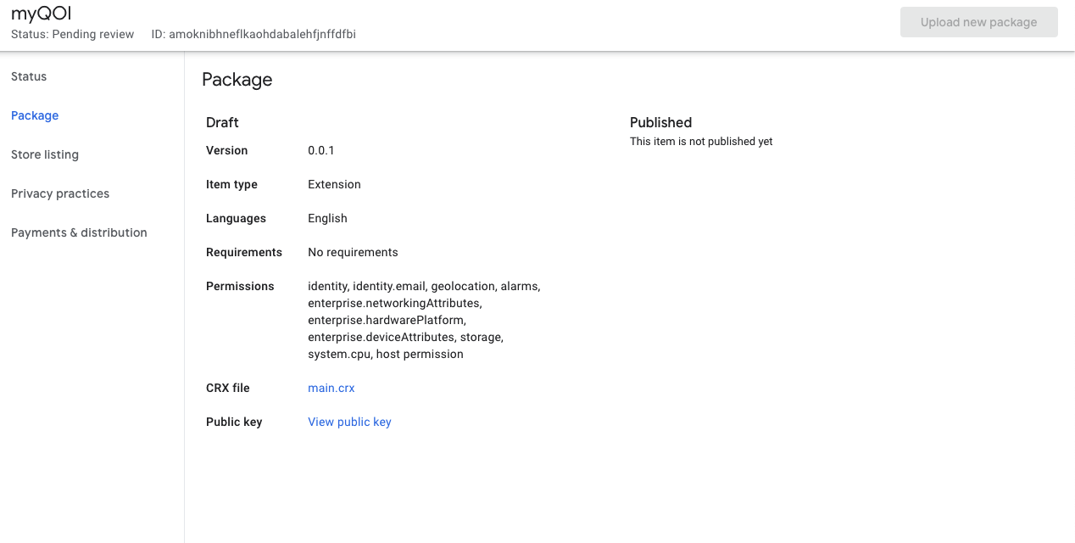
5. Click upload new package  
   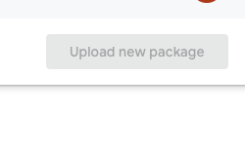
6. Once uploaded you can request to publish.
   1. Note: In this example the package is already pending review.

Notes:

* It is important to fill out the store listing with a detailed description.
* It is important to describe why you are using specific permissions in the chrome app in the privacy practices section.
* Payments and distribution tab is where the visibility – Unlisted is located.

# Deployment Steps for Azure Functions

Microsoft’s Guide:

Follow the Microsoft guide to add your functions to your workspace.

<https://docs.microsoft.com/en-us/azure/azure-functions/functions-develop-vs-code?tabs=csharp>

1. After logging into Azure you can select the resource you are trying to deploy. In this case we would redeploy myqoi under the Future State Azure Environment 1 > Function App
2. Right click on myqoi and click deploy to function app. This will repackage and deploy the azure functions and restart them. Any time a change is made to the azure functions they will need to be redeployed this way.

